Elliptical Curvilinear Shapes
# Source: AI Source: Provided by: [Data Path: Persons Table -> ID Column: 1, Name_En Column: Motasem Essam] -> From: [ChatGPT] on [7/25/2026]
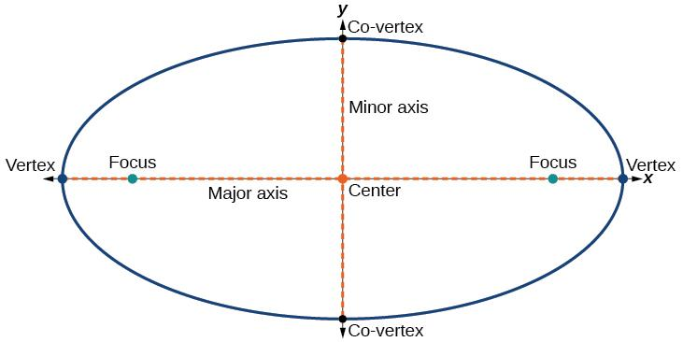
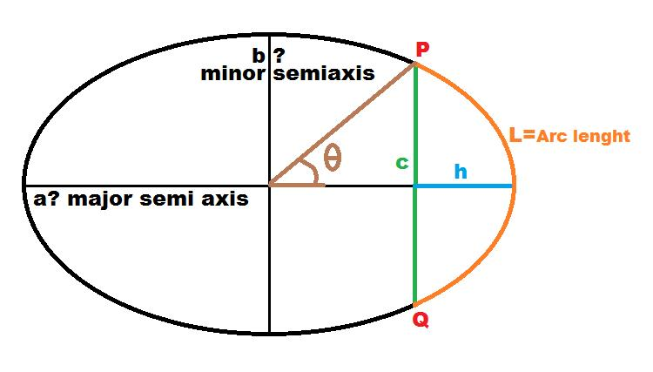
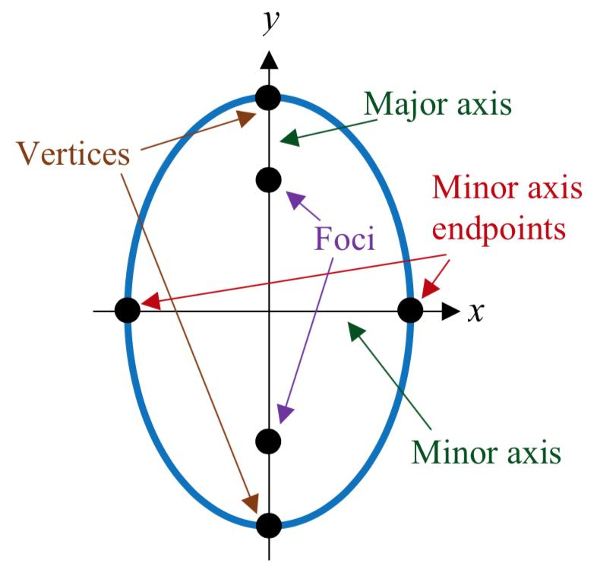
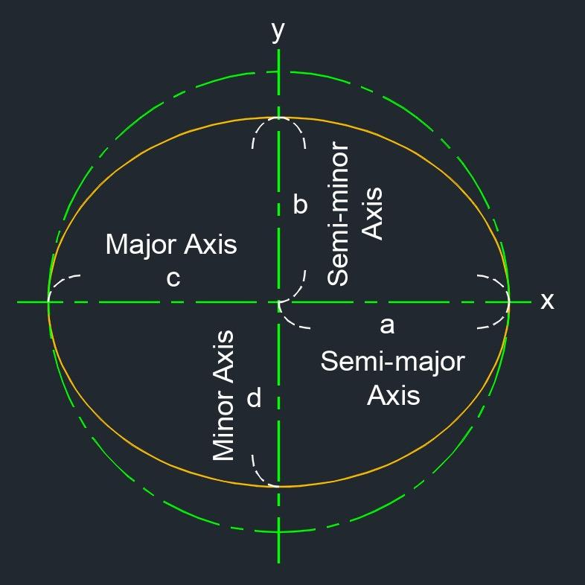

Definition
# Source: AI Source: Provided by: [Data Path: Persons Table -> ID Column: 1, Name_En Column: Motasem Essam] -> From: [ChatGPT] on [7/25/2026]
Elliptical Curvilinear Shapes are curvilinear shapes whose curved boundaries are formed primarily by ellipses or elliptical arcs.
An ellipse is a smooth, closed curve in which the sum of the distances from every point on the curve to two fixed points, called the foci, is constant.
Elliptical curvilinear shapes can consist of a complete ellipse, a portion of an ellipse, or a region bounded by one or more elliptical arcs.

Fundamental Concept
# Source: AI Source: Provided by: [Data Path: Persons Table -> ID Column: 1, Name_En Column: Motasem Essam] -> From: [ChatGPT] on [7/25/2026]
The fundamental geometric object is the ellipse.
For an ellipse centered at (h, k):
$$\frac{{\left(x-h\right)}^{2}}{a^{2}}+\frac{{\left(y-k\right)}^{2}}{b^{2}}=1$$
where:
- (h, k) = center
- a = semi-major axis
- b = semi-minor axis
- 2a = major-axis length
- 2b = minor-axis length
Usually:
$$a≥b>0$$
The foci are located at:
$$\left(h , ±ck\right)$$
where:
$$c=\sqrt{a^{2}-b^{2}}$$

Main Characteristics
# Source: AI Source: Provided by: [Data Path: Persons Table -> ID Column: 1, Name_En Column: Motasem Essam] -> From: [ChatGPT] on [7/25/2026]
Elliptical curvilinear shapes generally have the following characteristics:
- Their boundaries contain elliptical curves or elliptical arcs.
- Their curves are smooth rather than made from straight segments.
- A complete ellipse is a closed curve.
- An elliptical arc can be an open curve.
- An ellipse has a defined center.
- An ellipse has a major axis and a minor axis.
- An ellipse has two foci.
- Unlike a circle, an ellipse generally has variable curvature.
- An ellipse has reflection symmetry about both its major and minor axes.
- A non-circular ellipse does not have continuous rotational symmetry.

Basic Structure of an Ellipse
# Source: AI Source: Provided by: [Data Path: Persons Table -> ID Column: 1, Name_En Column: Motasem Essam] -> From: [ChatGPT] on [7/25/2026]
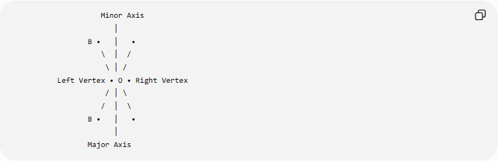
Minor Axis
│
B • │ •
\ │ /
\ │ /
Left Vertex • O • Right Vertex
/ │ \
/ │ \
B • │ •
│
Major Axis
More precisely:
- Center → O
- Major axis → longest diameter
- Minor axis → shortest diameter
- Vertices → endpoints of the major axis
- Co-vertices → endpoints of the minor axis
- Foci → two fixed points inside the ellipse

Types of Elliptical Curvilinear Shapes
# Source: AI Source: Provided by: [Data Path: Persons Table -> ID Column: 1, Name_En Column: Motasem Essam] -> From: [ChatGPT] on [7/25/2026]
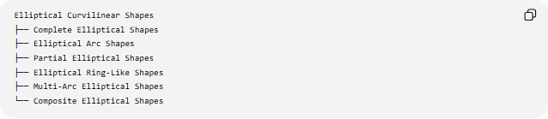
Elliptical Curvilinear Shapes
├── Complete Elliptical Shapes
├── Elliptical Arc Shapes
├── Partial Elliptical Shapes
├── Elliptical Ring-Like Shapes
├── Multi-Arc Elliptical Shapes
└── Composite Elliptical Shapes
Terminology note: Unlike circular sectors and circular segments, terms such as elliptical sector and elliptical segment are not universally standardized. It is therefore safer to describe these as regions bounded by elliptical arcs when mathematical precision is important.

Complete Elliptical Shapes
# Source: AI Source: Provided by: [Data Path: Persons Table -> ID Column: 1, Name_En Column: Motasem Essam] -> From: [ChatGPT] on [7/25/2026]
A Complete Elliptical Shape is formed by a complete ellipse.
The boundary is a continuous closed elliptical curve.
Examples:
- Ellipse
- Horizontal ellipse
- Vertical ellipse
- Rotated ellipse
Area
$$\boxed{A=πab}$$
where a and b are the semi-major and semi-minor axes.
Symmetry
A standard ellipse has:
- reflection symmetry about the major axis
- reflection symmetry about the minor axis
- rotational symmetry of order 2
A circle is a special case of an ellipse where:
$$a=b$$

Elliptical Arc Shapes
# Source: AI Source: Provided by: [Data Path: Persons Table -> ID Column: 1, Name_En Column: Motasem Essam] -> From: [ChatGPT] on [7/25/2026]
An Elliptical Arc Shape consists of only a portion of an ellipse.
An elliptical arc may connect two points on the ellipse without completing the entire boundary.
Parametrically, an ellipse can be represented by:
$$x=h+a\cos{t} \\ y=k+b\sin{t}$$
An elliptical arc corresponds to a restricted interval:
$$t_{1}≤t≤t_{2}$$
Unlike a complete ellipse, an elliptical arc is generally open.
Important distinction
A circular arc has a simple arc-length formula:
$$L=rθ$$
An elliptical arc generally does not have an elementary closed-form arc-length formula.

Partial Elliptical Shapes
# Source: AI Source: Provided by: [Data Path: Persons Table -> ID Column: 1, Name_En Column: Motasem Essam] -> From: [ChatGPT] on [7/25/2026]
A Partial Elliptical Shape is a region or form constructed from only part of an ellipse.
Examples include:
- half of an ellipse
- quarter of an ellipse
- elliptical caps
- regions bounded by an elliptical arc and a straight segment
For example, half of an ellipse has area:
$$A=\frac{1}{2}πab$$
A quarter ellipse has area:
$$A=\frac{1}{4}πab$$
These are descriptive classifications rather than universally standardized shape names.

Elliptical Ring-Like Shapes
# Source: AI Source: Provided by: [Data Path: Persons Table -> ID Column: 1, Name_En Column: Motasem Essam] -> From: [ChatGPT] on [7/25/2026]
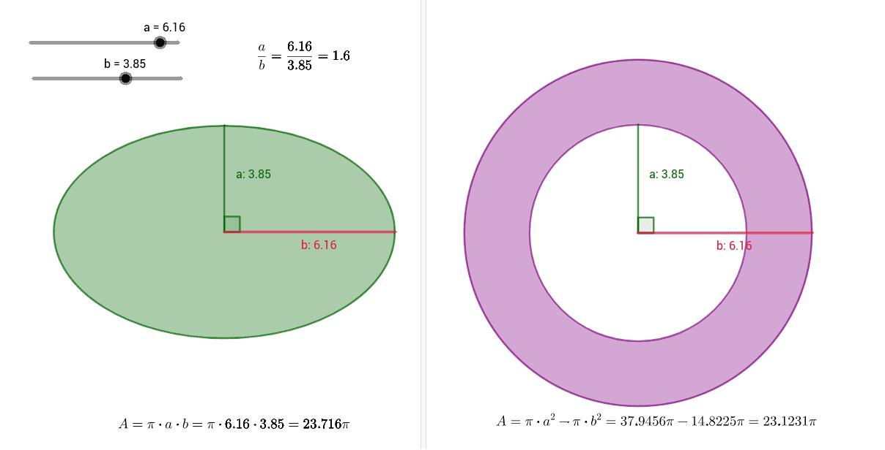
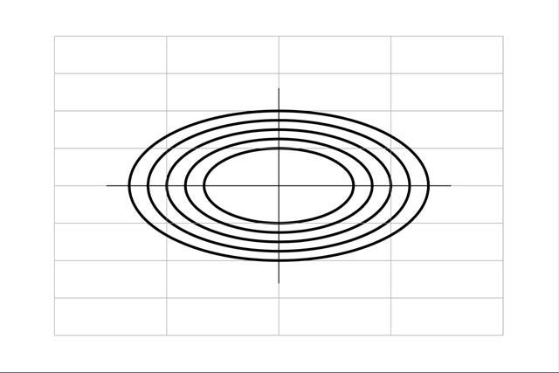
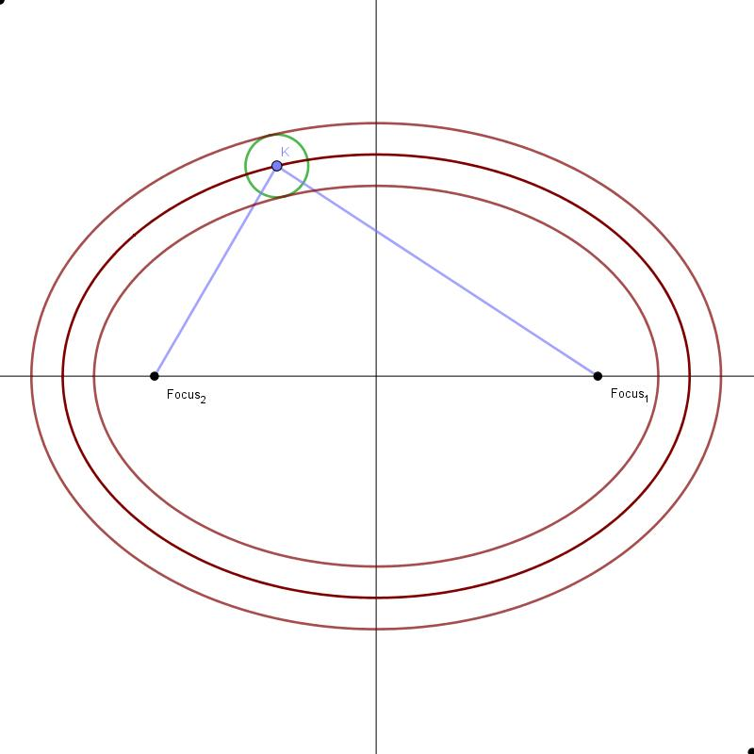
An Elliptical Ring-Like Shape is a region between two similarly centered ellipses.
For example:
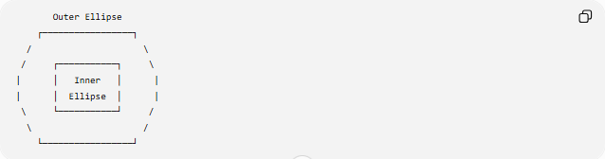
Outer Ellipse
┌─────────────────┐
/ \
/ ┌───────────┐ \
| │ Inner │ |
| │ Ellipse │ |
\ └───────────┘ /
\ /
└─────────────────┘
If the ellipses have the same center and semi-axis lengths:
- Outer ellipse: A_o, B_o
- Inner ellipse: A_i, B_i
then the ring-like area is:
$$\boxed{A=πA_{o}B_{o}-πA_{i}B_{i}}$$
or:
$$\boxed{A=π\left(A_{o}B_{o}-A_{i}B_{i}\right)}$$
This is analogous to an annulus, but the boundaries are elliptical rather than circular.

Multi-Arc Elliptical Shapes
# Source: AI Source: Provided by: [Data Path: Persons Table -> ID Column: 1, Name_En Column: Motasem Essam] -> From: [ChatGPT] on [7/25/2026]
A Multi-Arc Elliptical Shape contains multiple elliptical arcs.
The arcs may:
- belong to the same ellipse
- belong to different ellipses
- have different sizes
- have different orientations
- meet at endpoints
For example:
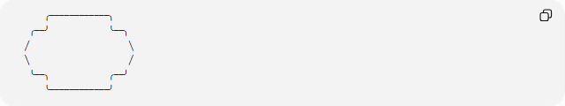
╭────────────╮
╭──╯ ╰──╮
╱ ╲
╲ ╱
╰──╮ ╭──╯
╰────────────╯
These shapes are particularly common in:
- technical drawing
- architecture
- product design
- computer graphics
- engineering profiles

Composite Elliptical Shapes
# Source: AI Source: Provided by: [Data Path: Persons Table -> ID Column: 1, Name_En Column: Motasem Essam] -> From: [ChatGPT] on [7/25/2026]
A Composite Elliptical Shape combines elliptical curves with other geometric elements.
For example:
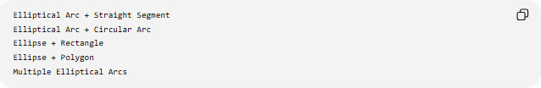
Elliptical Arc + Straight Segment
Elliptical Arc + Circular Arc
Ellipse + Rectangle
Ellipse + Polygon
Multiple Elliptical Arcs
A composite boundary may therefore contain both curved and straight portions.
Its total perimeter can be expressed as:
$$P=L_{\text{ellipse}}+L_{\text{straight}}+L_{\text{other curves}}$$
when the individual boundary lengths can be determined.

Mathematical Representation
# Source: AI Source: Provided by: [Data Path: Persons Table -> ID Column: 1, Name_En Column: Motasem Essam] -> From: [ChatGPT] on [7/25/2026]
Cartesian Form
For an axis-aligned ellipse:
$$\boxed{\frac{{\left(x-h\right)}^{2}}{a^{2}}+\frac{{\left(y-k\right)}^{2}}{b^{2}}=1}$$
Parametric Form
$$\boxed{x=h+a\cos{t}} \\ \boxed{y=k+b\sin{t}}$$
where:
$$0≤t≤2π$$
represents the complete ellipse.
Rotated Ellipse
A rotated ellipse can be represented parametrically as:
$$x=h+a\cos{t}\cos{θ}-b\sin{t}\sin{θ} \\ y=k+a\cos{t}\sin{θ}+b\sin{t}\cos{θ}$$
where θ is the rotation angle.

Important Measurements
# Source: AI Source: Provided by: [Data Path: Persons Table -> ID Column: 1, Name_En Column: Motasem Essam] -> From: [ChatGPT] on [7/25/2026]
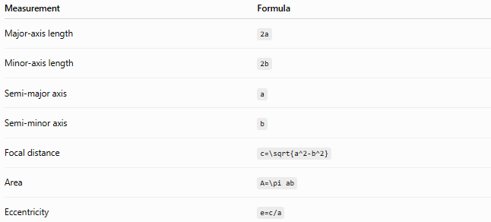
Measurement | Formula
Major-axis length | 2a
Minor-axis length | 2b
Semi-major axis | a
Semi-minor axis | b
Focal distance | c=\sqrt{a^2-b^2}
Area | A=\pi ab
Eccentricity | e=c/a
For an ellipse:
$$0≤e<1$$
A circle has:
$$e=0$$

Ellipse Perimeter
# Source: AI Source: Provided by: [Data Path: Persons Table -> ID Column: 1, Name_En Column: Motasem Essam] -> From: [ChatGPT] on [7/25/2026]
Unlike the circumference of a circle, the perimeter of an ellipse does not generally have a simple elementary exact formula.
A common approximation is:
$$P≈π\left[3\left(a+b\right)-\sqrt{\left(3a+b\right)\left(a+3b\right)}\right]$$
This is a useful approximation, but it is not the exact general perimeter.
The exact perimeter can be expressed using an elliptic integral.

Curvature
# Source: AI Source: Provided by: [Data Path: Persons Table -> ID Column: 1, Name_En Column: Motasem Essam] -> From: [ChatGPT] on [7/25/2026]
One important difference between circles and ellipses is their curvature.
For a parametric ellipse:
$$x=a\cos{t}, y=b\sin{t}$$
the curvature is:
$$\boxed{κ\left(t\right)=\frac{ab}{{\left(a^{2}\sin^{2}t+b^{2}\cos^{2}t\right)}^{3/2}}}$$
Therefore, the curvature changes as the point moves around the ellipse.
For a circle:
$$κ=\frac{1}{r}$$
which is constant.
Thus:
Circle → constant curvature
Ellipse → generally variable curvature

Symmetry
# Source: AI Source: Provided by: [Data Path: Persons Table -> ID Column: 1, Name_En Column: Motasem Essam] -> From: [ChatGPT] on [7/25/2026]
A standard ellipse has two principal axes of symmetry.
Major-axis reflection
Reflecting the ellipse across its major axis produces the same ellipse.
Minor-axis reflection
Reflecting it across its minor axis also produces the same ellipse.
Mathematically:
$$S_{x}\left(E\right)=E$$
and
$$S_{y}\left(E\right)=E$$
for an appropriately centered axis-aligned ellipse.
It also has 180° rotational symmetry:
$$R_{{180}^{∘}}\left(E\right)=E$$

Elliptical Curvilinear Shapes vs Circular Curvilinear Shapes
# Source: AI Source: Provided by: [Data Path: Persons Table -> ID Column: 1, Name_En Column: Motasem Essam] -> From: [ChatGPT] on [7/25/2026]
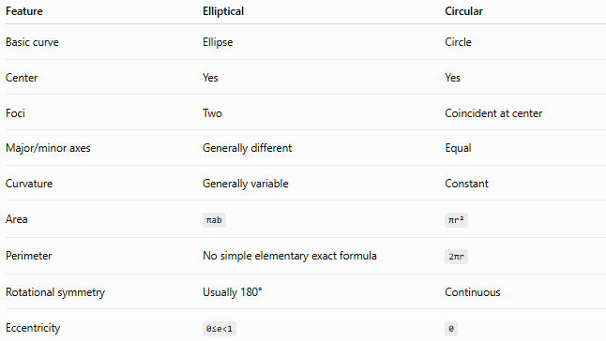
Feature | Elliptical | Circular
Basic curve | Ellipse | Circle
Center | Yes | Yes
Foci | Two | Coincident at center
Major/minor axes | Generally different | Equal
Curvature | Generally variable | Constant
Area | πab | πr²
Perimeter | No simple elementary exact formula | 2πr
Rotational symmetry | Usually 180° | Continuous
Eccentricity | 0≤e<1 | 0

Elliptical Curvilinear Shapes vs Freeform Curvilinear Shapes
# Source: AI Source: Provided by: [Data Path: Persons Table -> ID Column: 1, Name_En Column: Motasem Essam] -> From: [ChatGPT] on [7/25/2026]
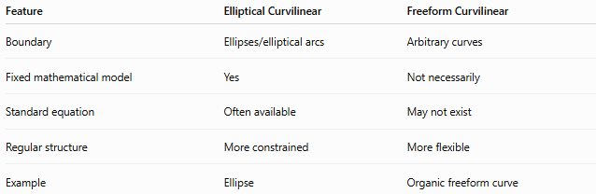
Feature | Elliptical Curvilinear | Freeform Curvilinear
Boundary | Ellipses/elliptical arcs | Arbitrary curves
Fixed mathematical model | Yes | Not necessarily
Standard equation | Often available | May not exist
Regular structure | More constrained | More flexible
Example | Ellipse | Organic freeform curve
An elliptical shape is therefore curvilinear, but not every curvilinear shape is elliptical.

Classification Summary
# Source: AI Source: Provided by: [Data Path: Persons Table -> ID Column: 1, Name_En Column: Motasem Essam] -> From: [ChatGPT] on [7/25/2026]
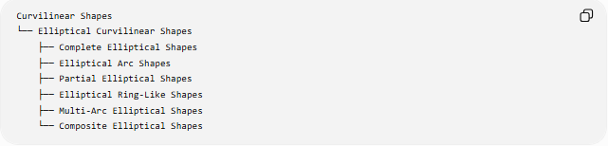
Curvilinear Shapes
└── Elliptical Curvilinear Shapes
├── Complete Elliptical Shapes
├── Elliptical Arc Shapes
├── Partial Elliptical Shapes
├── Elliptical Ring-Like Shapes
├── Multi-Arc Elliptical Shapes
└── Composite Elliptical Shapes
A more mathematical classification is:
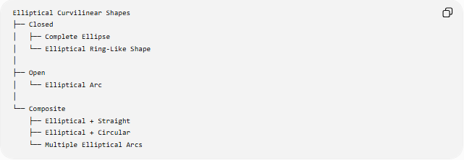
Elliptical Curvilinear Shapes
├── Closed
│ ├── Complete Ellipse
│ └── Elliptical Ring-Like Shape
│
├── Open
│ └── Elliptical Arc
│
└── Composite
├── Elliptical + Straight
├── Elliptical + Circular
└── Multiple Elliptical Arcs

Key Points
# Source: AI Source: Provided by: [Data Path: Persons Table -> ID Column: 1, Name_En Column: Motasem Essam] -> From: [ChatGPT] on [7/25/2026]
- Elliptical Curvilinear Shapes are shapes whose curved boundaries are based on ellipses or elliptical arcs.
- The fundamental curve is the ellipse.
- An ellipse has a center, major axis, minor axis, and two foci.
- The area of an ellipse is:
$$\boxed{A=πab}$$
- Elliptical curvature is generally variable.
- A complete ellipse is closed, while an elliptical arc is open.
- Elliptical ring-like shapes can be formed by placing one ellipse inside another with a common center.
- Terms such as elliptical sector and elliptical segment are less standardized than their circular counterparts, so descriptive terminology is preferable when precision matters.
- Elliptical shapes have two principal reflection axes and 180° rotational symmetry.
- A circle is a special case of an ellipse where:
$$a=b$$

Conclusion
# Source: AI Source: Provided by: [Data Path: Persons Table -> ID Column: 1, Name_En Column: Motasem Essam] -> From: [ChatGPT] on [7/25/2026]
Elliptical Curvilinear Shapes form a specialized class of curvilinear shapes based on the geometry of the ellipse. They include complete ellipses, elliptical arcs, partial elliptical forms, elliptical ring-like regions, multi-arc forms, and composite shapes.
Their defining feature is the use of elliptical curvature, distinguishing them from circular, wavy, and arbitrary freeform curvilinear shapes.

